

|  |  |  |
| --- | --- | --- |
| **QUANTITATIVE SCIENCES DEPARTMENT** | |  |
| **Course:** **A2MAA** | |
| **Topic Title**: **Investigation 2 – Applying Linear Relationships** | |
| Student Name:_____________________________________ | Date: __________2015 | | |
| Special Instructions: Scientific Calculators only, No Notes allowed | Time Allowed: 60 mins | | |
|  | Marks: / 50 | | |

Introduction

Some students are planning to set up a babysitting service in clients’ homes and they start by investigating existing businesses.

**Question 1 (5 marks)**

In the first business the students investigate there are three payment plans for the employees. The plans include a petrol allowance (a fixed amount to help with the cost of travelling to the work location) plus an hourly rate. The plans are summarised in the following table.

**Payment plans**

|  |  |  |
| --- | --- | --- |
| Plan | Petrol allowance ($) | Hourly rate ($) |
| A | 0 | 20 |
| B | 10 | 18 |
| C | 15 | 16 |

(a) Use the table above to determine the total payment to a babysitter for up to 6 hours at one time under each plan. Record your results in the table below. (4 marks)

**Total payments**

|  |  |  |  |  |  |
| --- | --- | --- | --- | --- | --- |
|  | Number of hours | | | | |
| Plan | 2 | 3 | 4 | 5 | 6 |
| A | $40 |  |  |  |  |
| B |  | $64 |  |  |  |
| C |  |  |  |  | $111 |

(b) If graphs are drawn showing the total payments as the number of hours increases for each plan, they will be linear. Give two reasons to explain how you know, from the information given in these tables, that the graphs will be linear. (2 marks)

**Question 2 (6 marks)**

In the second business the students investigate, the payment for the babysitters is again a petrol allowance plus an hourly rate and the information is set out in the tables below. For each table, write the rule to calculate the payments using *P* ($) to represent the total payments and *h* to represent the number of hours of babysitting.

(a) Plan M

|  |  |  |  |  |  |
| --- | --- | --- | --- | --- | --- |
| Hours of babysitting(*h*) | 1 | 2 | 3 | 4 | 5 |
| Payment to employee (*P*) | $15 | $30 | $45 | $60 | $75 |

(b) Plan N

|  |  |  |  |  |  |
| --- | --- | --- | --- | --- | --- |
| Hours of babysitting(*h*) | 1 | 2 | 3 | 4 | 5 |
| Payment to employee (*P*) | $35 | $55 | $75 | $95 | $115 |

(c) Plan Q

|  |  |  |  |  |  |
| --- | --- | --- | --- | --- | --- |
| Hours of babysitting(*h*) | 1 | 2 | 3 | 4 | 5 |
| Payment to employee (*P*) | $30 | $45 | $60 | $75 | $90 |

**Question 3 (8 marks)**

The third business has its payment plans represented by the graph given below.

Again, there was a petrol allowance plus an hourly payment.

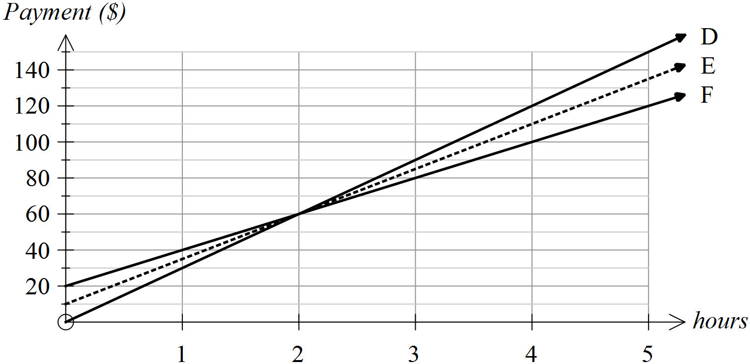

(a) From the graph determine the total payments for working for 2, 4 and 5 hours and use these results to complete the table below. (3 marks)

**Total payments**

|  |  |  |  |
| --- | --- | --- | --- |
|  | Number of hours of babysitting | | |
| Plan | 2 | 4 | 5 |
| D |  |  |  |
| E |  |  |  |
| F |  |  |  |

(b) What is the petrol allowance under (3 marks)

(i) Plan D

(ii) Plan E

(iii) Plan F

(c) Plan D has the highest hourly rate. From what information on the graph can you draw this conclusion? (1 mark)

(d) What feature of these graphs shows that payments can be equal when hours worked are equal? (1 mark)

**Question 4 (4 marks)**

Consider all the businesses described in Questions 1-3. State the

(a) maximum petrol allowance

(b) minimum petrol allowance

(c) highest hourly rate

(d) lowest hourly rate

**Question 5 (7 marks)**

Another business shows its payment schedules for four different plans (i.e., W, X, Y, Z) as graphs. The payments consist of a petrol allowance and an hourly rate.

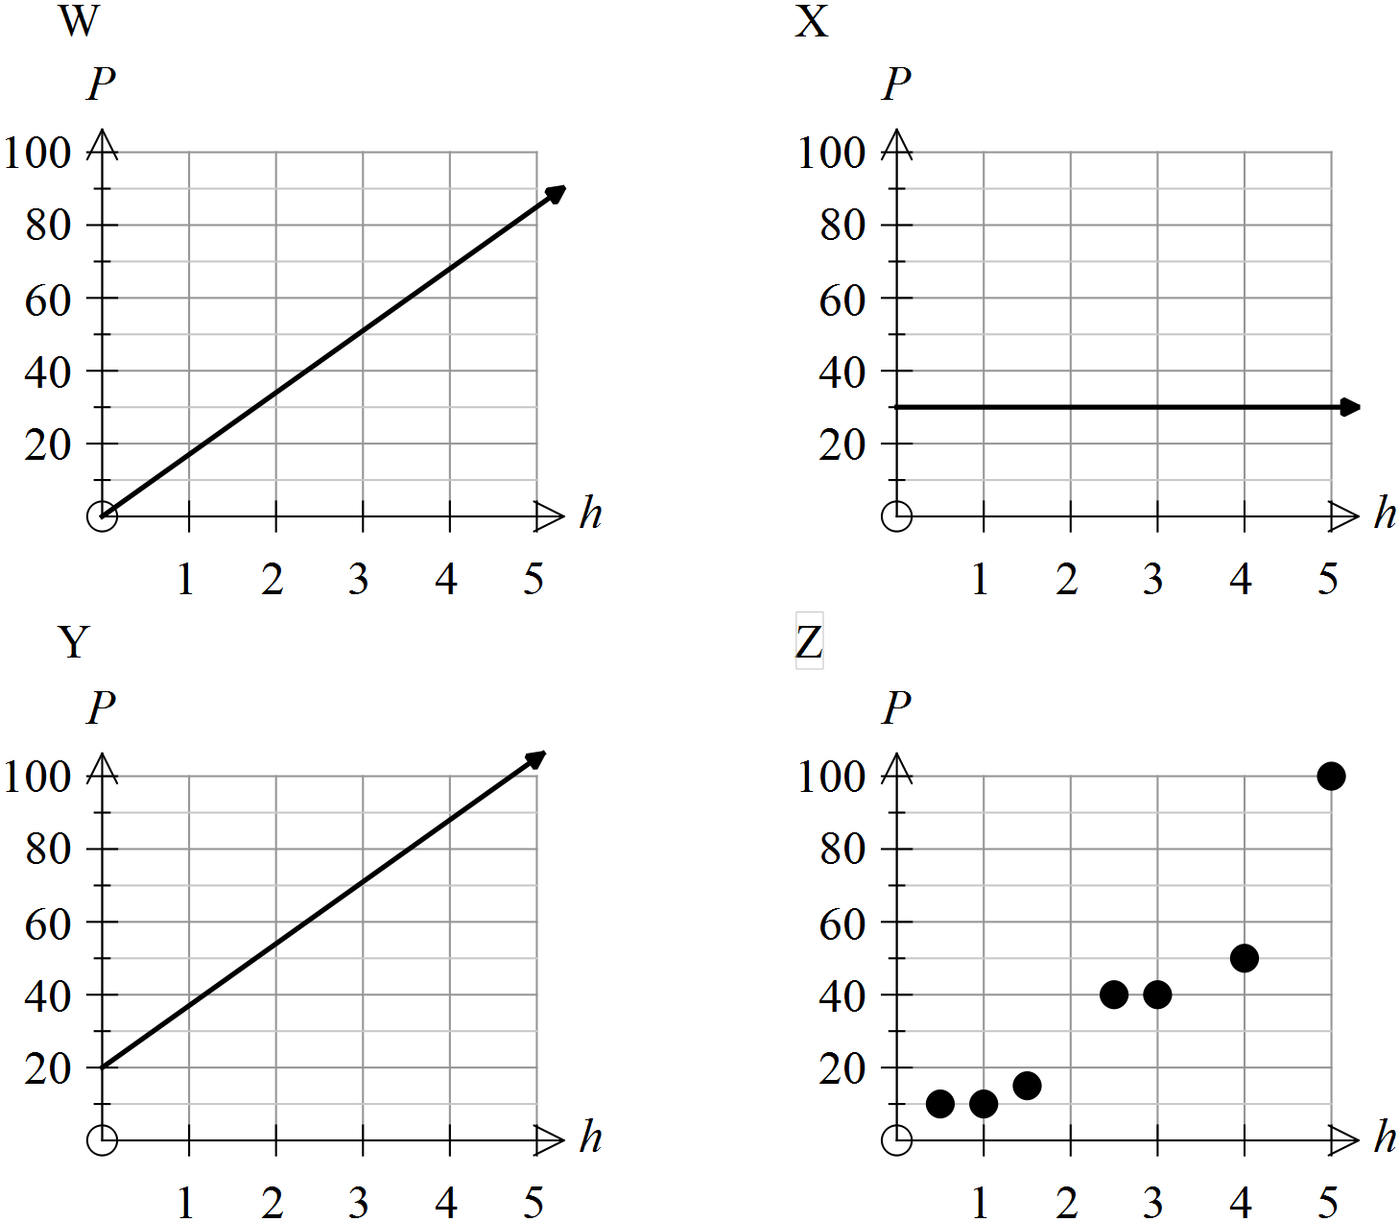

Use the letters of the graphs (i.e., W, X, Y, Z) to name the plans with the following features.

(i) The plans for which the hourly rate is the same.

(ii) The plan which shows that total payment is not linearly related to the number of hours worked.

(iii) The plan(s) for which the payment for 1 hour of babysitting is the highest.

(iv) The plan(s) in which payments can be the same for different numbers of hours worked.

(v) The plan(s) for which there is no petrol allowance.

**Question 6 (19 marks)**

The students decided to set up a sliding scale of payments based on the number of years experience in babysitting. Their schedule is as follows.

**Business schedule of payment**

|  |  |  |  |  |
| --- | --- | --- | --- | --- |
| No. years experience | Hourly rate | Petrol allowance | Rule to calculate  Payment | Payment for 5 hours work |
| 0 | 10 | 10 |  |  |
| 1 | 15 | 10 |  |  |
| 2-5 | 20 | 25 |  |  |
| >5 | 25 | 30 |  |  |

(a) Complete the table. Let *K* represent total payment ($) and *r* the time (number of hours) worked (6 marks)

(b) On the axes provided below, draw graphs to represent the total payments, for up to 5 hours of babysitting according to years of experience. (6 marks)

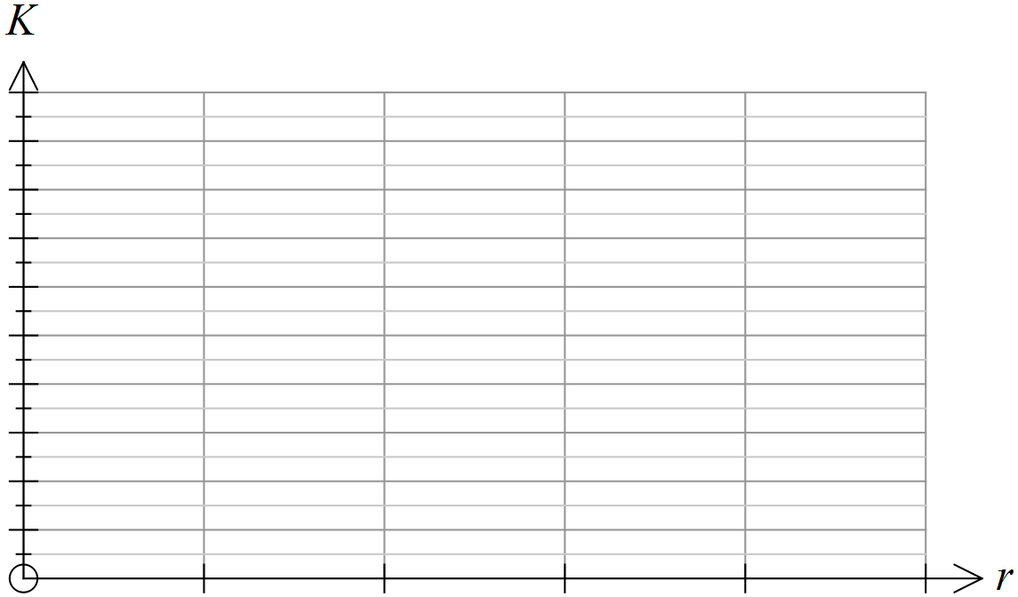

(c) According to the students’ schedule, how much should have been paid out when the following work was done? (3 marks)

(i) Joel has had 3 years of babysitting experience and he worked both Friday and Saturday nights, each for 3 hours.

(ii) Billy is new to babysitting and he did 2 hours work on Sunday afternoon.

(iii) Brooke has over 10 years experience with babysitting and she worked on Saturday night for 4 hours.

(d) The total amount paid out one week was $1000. Describe how this could have happened with Joel, Billy and/or Brooke working with this schedule of fees. (4 marks)

**End of questions**